TIC TAC TOE GAME CIRCUIT USING LOGISIM
Subject Name: Computation Structures
Academic year-2025-2026

Ojas Kumar Kashyap - 25BCE0721
Sushil Kumar Shourya - 25BCE0775

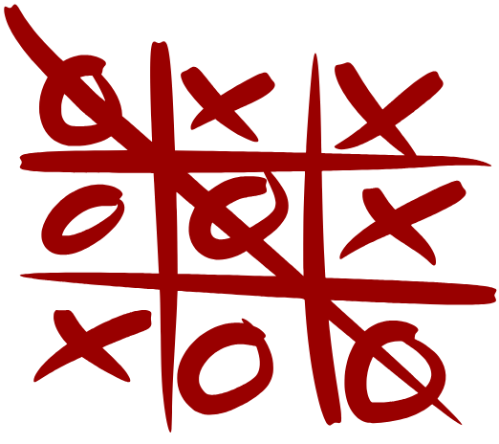

Project Title :
TIC TAC TOE GAME CIRCUIT USING LOGISIM SOFTWARE

Abstract:
This project presents the design and implementation of a Tic Tac Toe game circuit using Logisim software. The project focuses on creating a digital logic-based system that simulates the popular Tic Tac Toe game through combinational and sequential logic circuits. The circuit uses logic gates, multiplexers, and flip-flops to represent player moves and determine the winner based on logical conditions. This project demonstrates how fundamental digital logic concepts can be applied to develop interactive systems. The implementation was successfully simulated in Logisim, and the circuit accurately displays game outcomes such as win, draw, or ongoing status.

Keywords: Digital Logic, Logisim, Tic Tac Toe, Combinational Circuit, Sequential Logic.
1.Introduction:
Digital systems form the backbone of modern computing and embedded systems. Designing interactive circuits like games helps in understanding how logical operations can be combined to achieve complex functionalities.
This project, Tic Tac Toe Game Circuit using Logisim Software, is based on basic logic gate design and digital logic principles. The purpose is to simulate a two-player game where each player alternately places their mark (“X” or “O”) on a 3×3 grid. The circuit checks the winning condition by analyzing possible combinations across rows, columns, and diagonals.
The project aims to:
- Develop a fully functional Tic Tac Toe game circuit.
- Implement logical conditions to determine the winner.
- Use Logisim as a simulation tool to visualize and test the circuit.
This project is a creative demonstration of computation structures and digital electronics, bridging theory and practical circuit design.
2.Proposed Methodology :
The development process involved several stages:
- Circuit Design Approach
The game was implemented using:
- Logic Gates – for condition checking.
- Multiplexers and Decoders – to select and display positions.
- Flip-Flops – to store player moves.
- LEDs – to display the results or active states.
Each cell of the 3×3 grid is represented by a binary input, and the system evaluates combinations to detect a win. Logical equations were designed for all eight possible winning conditions.
- Implementation in Logisim software
The entire circuit was designed and simulated using Logisim, a free educational software for digital logic design.
Steps followed:
- Designed input switches for player positions.
- Implemented logic gates for all winning conditions (rows, columns, diagonals).
- Added logic for “Player 1 wins”, “Player 2 wins”, or “Draw” conditions.
- Connected output LEDs for result display.
- Verified all logical outputs using simulation in Logisim.
- Circuit design

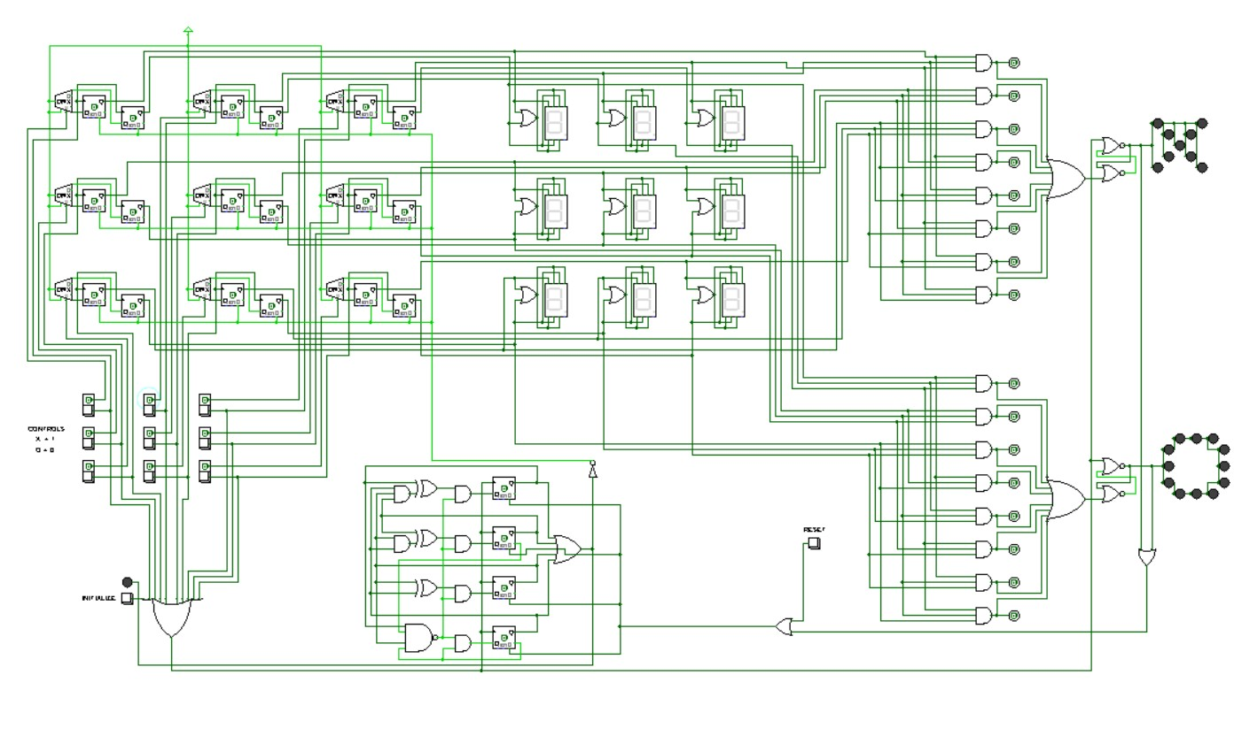
3.Pseudo codes:
Storage unit
INPUT: Button
COMPONENTS: 1:2 DEMUX, 2-bit PIPO Register (D1, D2 from D-FlipFlops)

PROCESS:
1. Button → DEMUX select line
2. DEMUX outputs (Y0, Y1) → Inputs of D-flipflops in 2-bit PIPO Register
Display unit
INPUTS: D1, D2 (outputs of PIPO Register D-flipflops)
COMPONENTS: AND gate, 7-segment display

PROCESS:
1. (D1 AND D2) → segments b, c, e, f of 7-segment display
2. D1 → segment g of 7-segment display
3. D2 → segments a, d of 7-segment display
Win detector
COMPONENTS: 8 AND gates (3-input each)
INPUTS: Outputs of 9 cells (7-segment displays labeled 1–9)

PROCESS:
FOR each winning combination (rows, columns, diagonals):
CONNECT 3 corresponding cell outputs → inputs of one 3-input AND gate
Win showing
COMPONENTS: OR gate, SR-latch, LED pattern (X, O)

PROCESS:
1. Outputs of 8 AND gates (from WIN DETECTOR) → OR gate
2. OR gate output → SR-latch
3. SR-latch output → LED pattern (X, O)
Control unit
COMPONENTS: 9 clickable buttons, Initialize button, 10-input OR gate, MOD-11 counter, SR-latch

PROCESS:
1. Each clickable button → respective register input
2. All 9 clickable buttons + Initialize button → 10-input OR gate
3. OR gate output →
a. Clock input of MOD-11 counter
b. Reset pin of SR-latch

Reset function
COMPONENTS: SR-latches (X, O), AND gates, clickable button, MOD-11 counter, OR gate, NOT gate, PIPO registers

PROCESS:
1. Output of X SR-latch AND Output of O SR-latch → AND1
2. AND1 output AND clickable button → AND2
3. AND2 output → Clear pins of MOD-11 counter D-flipflops

4. Outputs of MOD-11 counter D-flipflops → OR gate
5. OR gate output → NOT gate
6. NOT gate output → Clear pins of all D-flipflops in PIPO registers (Storage Unit)
MOD-11 counter
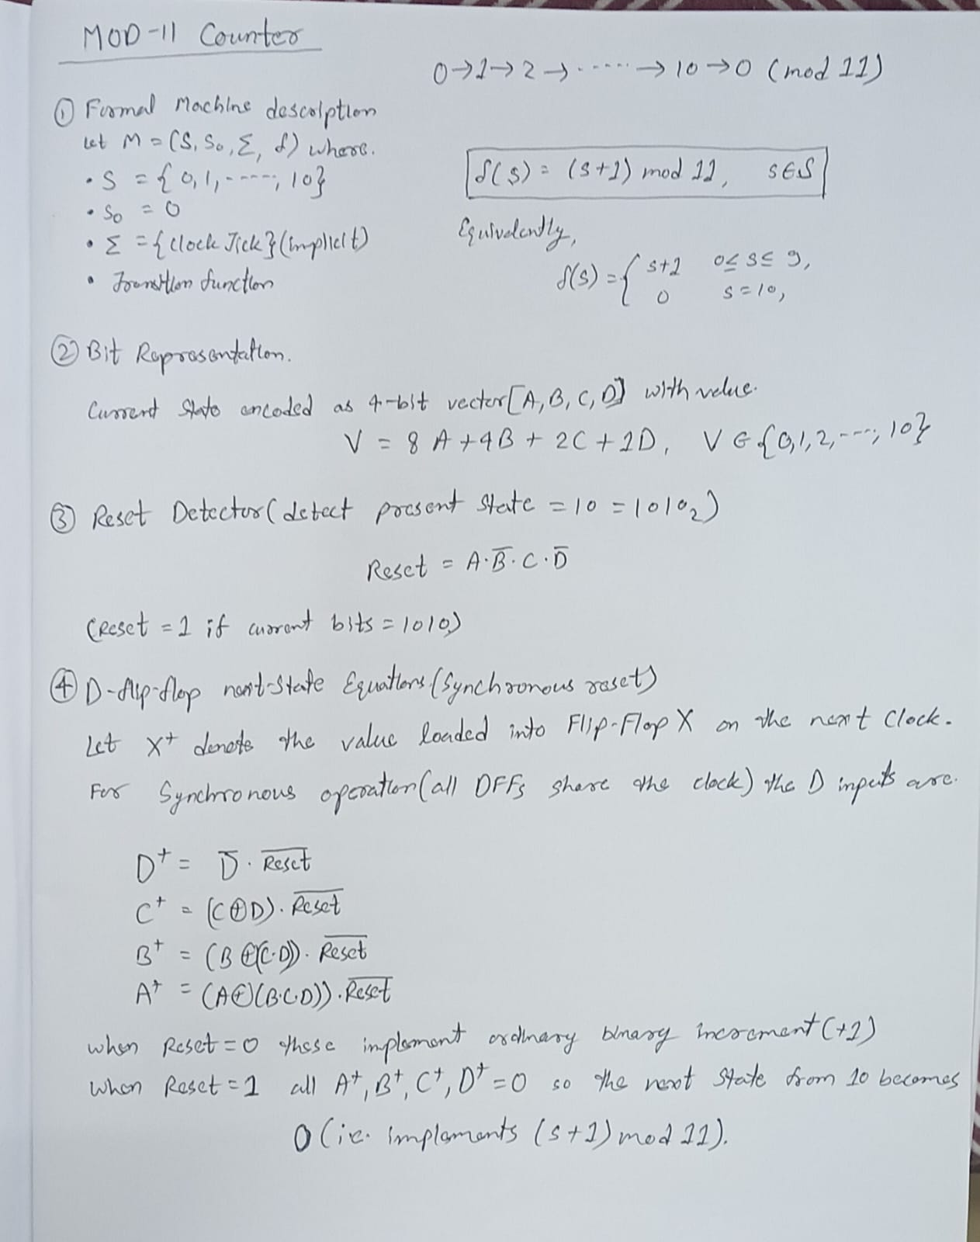

4.Results and Discussion:
After successful design and simulation:
- The circuit correctly displayed winning outputs for all possible combinations.
- No overlap or false triggering was observed during simultaneous player inputs.
- The LED indicators and output display effectively represented the state of the game.

5. Conclusion
This project successfully implements a Tic Tac Toe Game Circuit using Logisim software. It highlights the application of combinational and sequential logic in designing an interactive game system. The circuit verifies winning conditions through Boolean equations and logical gates, displaying results accurately through simulation.
Future improvements can include integrating a display module, timer, or automatic move reset system to make the circuit more user-friendly and efficient.

References
- Logisim Documentation – https://sourceforge.net/projects/circuit/
- Mano, M. Morris. Digital Design, Pearson Education.
- Floyd, Thomas L. Digital Fundamentals, Pearson.
- TutorialsPoint – Digital Logic Design Basics.
- Apna College – Digital Electronics using Logisim (YouTube Tutorials).
- IEEE Xplore - https://ieeexplore.ieee.org/Xplore/home.jsp

